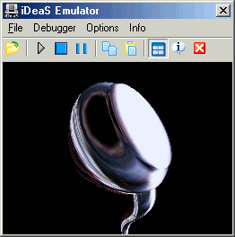
iDeaS is an Nintendo DS emulator.

